Project Title

Employee ID Card Request
Name : Paidisetti Chaitanya Lakshmi
College : Aditya Institute of Technology and Management
Email : 23a51a1242@adityatekkali.edu.in

Project Report

Date | 07/07/2026
Team ID | 23A51A1242
Project Name | Employee ID Card Request
Maximum Marks

Project Overview
The Employee ID Card Request System is a Service Catalog solution that automates the process of requesting new or replacement employee ID cards. Employees can submit their requests through an online catalog item by entering essential details such as Employee Name, Department, and the Reason for the request. This eliminates the need for paper forms and email-based requests, making the process faster, more organized, and easier for employees to use.

After a request is submitted, the system automatically routes it to the employee's manager for approval. The manager can review the request and either approve or reject it based on company policies. Once the request is approved, the system sends an automated notification to the employee informing them of the approval status. At the same time, a task is automatically created and assigned to the administration team, enabling them to prepare and issue the employee's ID card without unnecessary delays.

This automated workflow improves efficiency, transparency, and accountability across the organization. It reduces manual effort, minimizes processing errors, and provides real-time tracking of request status for both employees and administrators. The system also maintains

a complete history of requests, approvals, and task completion, making it useful for reporting and auditing purposes. Overall, the Employee ID Card Request System offers a reliable, secure, and standardized solution for managing employee ID card requests while improving the overall employee experience.

Table of Contents
- Introduction
- Project Objectives
- Key Features
- Project Milestones
- ServiceNow Developer Setup
- Project Implementation in ServiceNow
- Screenshots of Output
- Conclusion

Introduction :
In today's organizations, employee identification cards are essential for maintaining workplace security, controlling access to company premises, and verifying employee identity. Employees may need to request a new ID card when joining the organization or request a replacement due to loss, damage, theft, or changes in personal information. Managing these requests manually through emails, paper forms, or phone calls often leads to delays, missing approvals, administrative overhead, and inconsistent processing.

As organizations grow, the number of employee ID card requests increases, making manual request management inefficient and time-consuming. This can result in delayed card issuance, poor visibility into request status, difficulty in tracking approvals, and challenges in maintaining accurate records. Employees may also experience uncertainty about the progress of their requests, while administrators spend significant time coordinating approvals and processing requests manually.

The Employee ID Card Request System, developed using the ServiceNow platform, provides a centralized and automated solution for managing employee ID card requests. Employees can easily submit requests through the Service Catalog by entering details such as Employee Name, Department, and the Reason for the request. The system automatically validates the submitted information, routes the request to the employee's manager for approval, sends automated notifications after approval, creates tasks for the administration team to prepare the ID card, and tracks the request throughout its lifecycle.

The proposed system offers the following benefits:

Faster processing of new and replacement ID card requests Standardized and automated approval workflow

Reduced manual effort and administrative workload Automatic notifications to keep employees informed Improved transparency and real-time request tracking Efficient task assignment for the administration team Secure record management for auditing and reporting
Increased employee satisfaction through faster service delivery

By utilizing the low-code capabilities of ServiceNow, this project demonstrates how IT Service Management (ITSM) can automate employee ID card request processes, improve operational efficiency, ensure policy compliance, and provide a scalable solution that can be extended to support contractor badges, temporary access cards, and visitor pass management in the future.

Project Objectives :
The main objective of this project is to develop an Automated Employee ID Card Request System using the ServiceNow platform that reduces manual effort and improves the efficiency of processing employee ID card requests. The system provides employees with a simple and centralized platform to request new or replacement ID cards while automating the processes of request submission, approval, notifications, task creation, and request tracking. By replacing manual paper-based or email-based processes, the system ensures faster service delivery, improved transparency, and better record management.

The project also focuses on creating a standardized workflow that enhances operational efficiency, minimizes processing delays, and ensures that every ID card request follows the organization's approval policies. Automation helps reduce administrative workload, eliminates repetitive tasks, and provides real-time visibility into the request status for employees, managers, and the administration team.

The specific objectives of this project are:
Develop a centralized Service Catalog for submitting employee ID card requests.
Design an interactive catalog form with fields such as Employee Name, Department, and Reason for Request.
Implement Catalog Variables to capture accurate employee information.
Create UI Policies to dynamically display or hide fields based on the selected request reason.
Configure Flow Designer to automate the complete request processing workflow. Route ID card requests automatically to the employee's manager for approval.
Generate automatic email notifications after approval or rejection of the request.
Create and assign tasks automatically to the administration team for ID card preparation and issuance.
Maintain complete records of requests, approvals, and task completion for reporting and auditing purposes.
Build a scalable and user-friendly solution that can be extended in the future to support temporary ID cards, contractor badges, and visitor pass requests.

Key Features
The proposed system includes the following major features:

- User-friendly Service Catalog for submitting network requests.
- Dynamic forms with intelligent field visibility.
- Catalog Variables for capturing request information.
- Variable Sets for reusable user information.
- Automated approval workflows using Flow Designer.
- Custom Network Database table for request storage.
- Automatic creation of backend records.
- Email notifications during approval and completion stages.
- Real-time request status tracking.
- Audit-ready approval history.
- Scalable workflow architecture.
- Reduced manual processing time.

Project Milestones
The project implementation follows five major milestones.

Creating a ServiceNow Developer Account :
To begin development, perform the following steps:
- Visit the ServiceNow Developer Portal.
- Click Sign Up to create a free developer account.
- Enter the required information:
  - First Name
  - Last Name
  - Email Address
  - Password
- Verify the email address using the activation link sent to your registered email.
- Log in to the ServiceNow Developer Portal.
- Click Start Building.
- Request a Personal Developer Instance (PDI).
- Wait for the instance to be provisioned.
- Launch the instance and log in using the generated credentials.

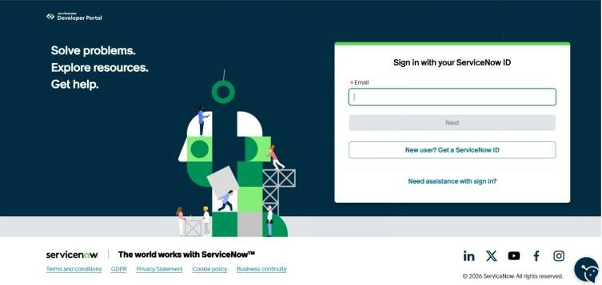

Milestone 1: Catalog Item Creation Objective
Create a Service Catalog Item for employees to request a new or replacement ID card.
Step 1: Open Maintain Items Navigation:
All → Service Catalog → Catalog Definitions → Maintain Items

Step 2: Create a New Catalog Item Click New.
Enter the following details:
Name: Employee ID Card Request Catalog: Service Catalog Category: Can We Help You?
Short Description: Request for a new or replacement employee ID card. Click Save.

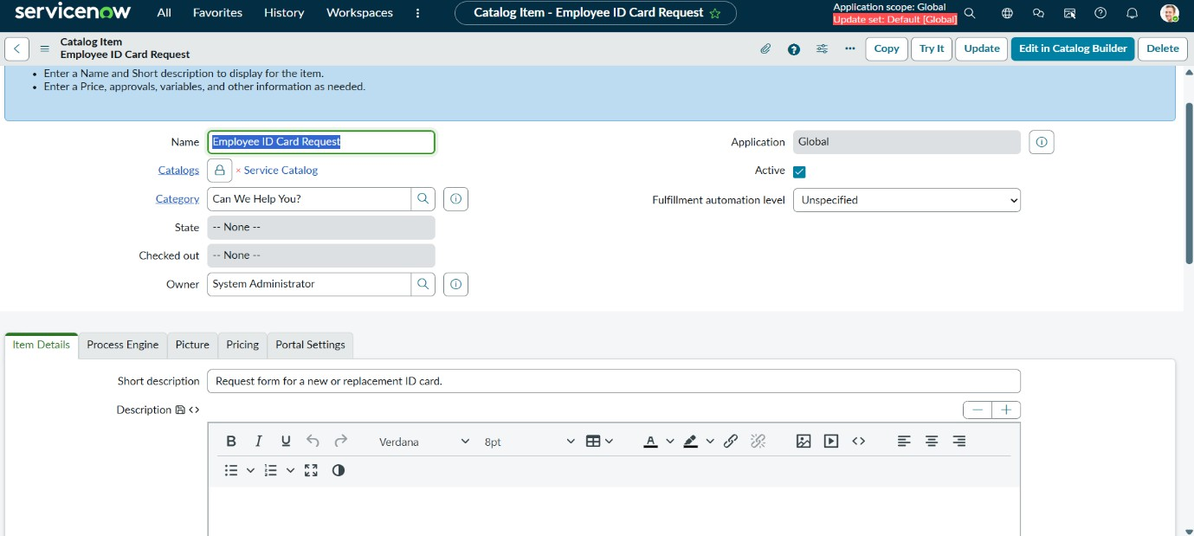

Step 3: Create Employee Name Variable Scroll to the Variables related list.
Click New. Configure:
Type: Reference Question: Employee Name
Reference Table: User [sys_user] Mandatory: True
Click Submit.
Step 4: Create Department Variable Click New under Variables.
Configure:
Type: Single Line Text Question: Department Mandatory: True
Click Submit.
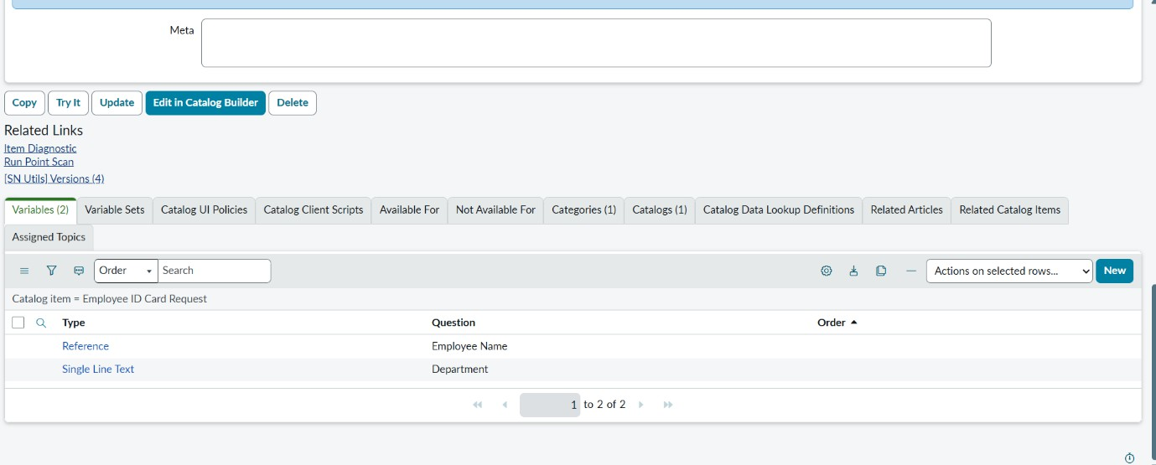

Step 5: Create Reason Variable Click New.
Configure:

Type: Select Box Question: Reason Mandatory: True Save the variable.
Open Question Choices. Add:
New ID Card Replacement ID Card Click Update.
Step 6: Preview the Catalog Item Open the Catalog Item.
Click Try It.
Verify Employee Name, Department, and Reason fields appear correctly.

Milestone 2: Flow Designer & Manager Approval Objective
Create an approval workflow using Flow Designer.
Step 1: Open Flow Designer Navigation:
All → Process Automation → Flow Designer

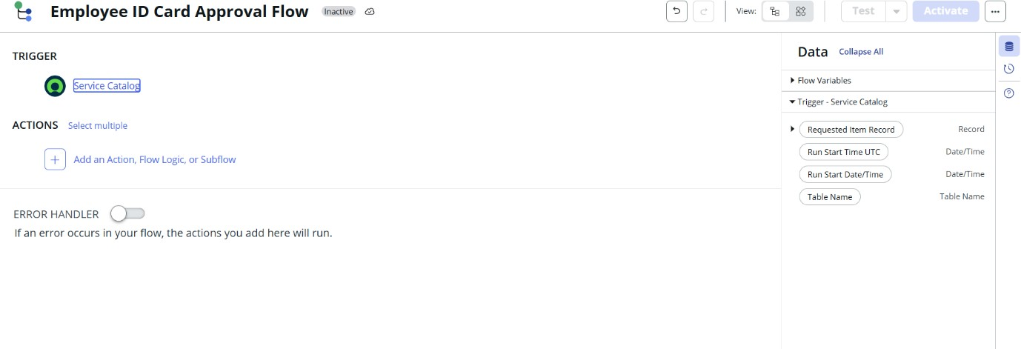

Step 2: Create a New Flow Click New.
Select Flow. Enter:
Flow Name: Employee ID Card Approval Flow Application: Global
Click Submit.

Step 3: Add Trigger Click Add Trigger. Select Service Catalog.

Click Done.
Step 4: Add Manager Approval Click Add Action.
Search Ask For Approval. Configure:
Record: Requested Item Record Approval Rule: Anyone Approves Approver: Requested For → Manager Click Done.

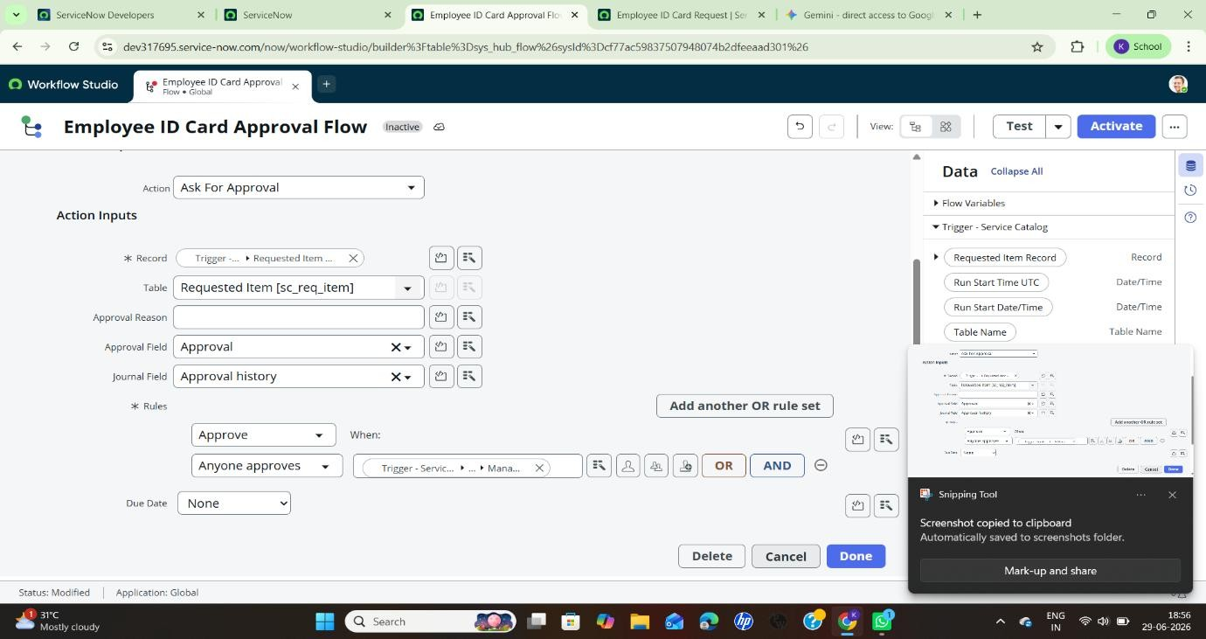

Milestone 3: Email Notifications Objective
Send automatic email notifications after approval or rejection.

Step 1: Configure Approval Condition Click Add Flow Logic.
Select If. Condition:
Approval State = Approved
Step 2: Send Approval Email
Inside the If Approved block, click Add Action. Select Send Email.
Configure:
To: Requested For Email
Subject: Your ID Card Request is Approved Body: Approval confirmation message.
Click Done.
Step 3: Configure Rejection Condition

Click Add Flow Logic.
Select Else If.
Condition:
Approval State = Rejected Step 4: Send Rejection Email Add Send Email.
Configure:
To: Requested For Email
Subject: Your ID Card Request is Rejected Body: Rejection notification.
Click Done.

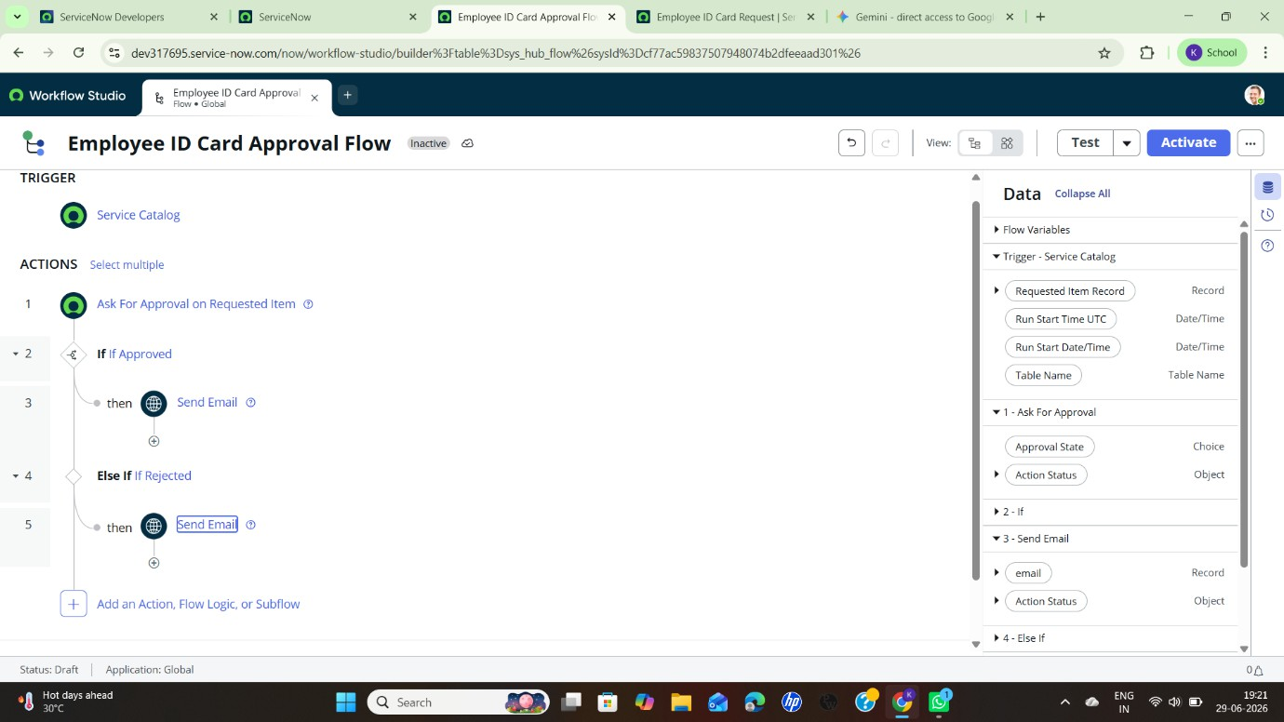

Milestone 4: Catalog Task Creation Objective
Create an administrative task after manager approval.

Step 1: Add Catalog Task
Inside the If Approved branch, click Add Action. Search Create Catalog Task.
Step 2: Configure Catalog Task Requested Item: Requested Item Record Short Description:
Print and Issue Employee ID Card Assignment Group:
Service Desk (or Admin Team) Click Done.
Step 3: Activate the Flow

Click Activate.
Confirm activation.
Ensure the flow status changes to Active.

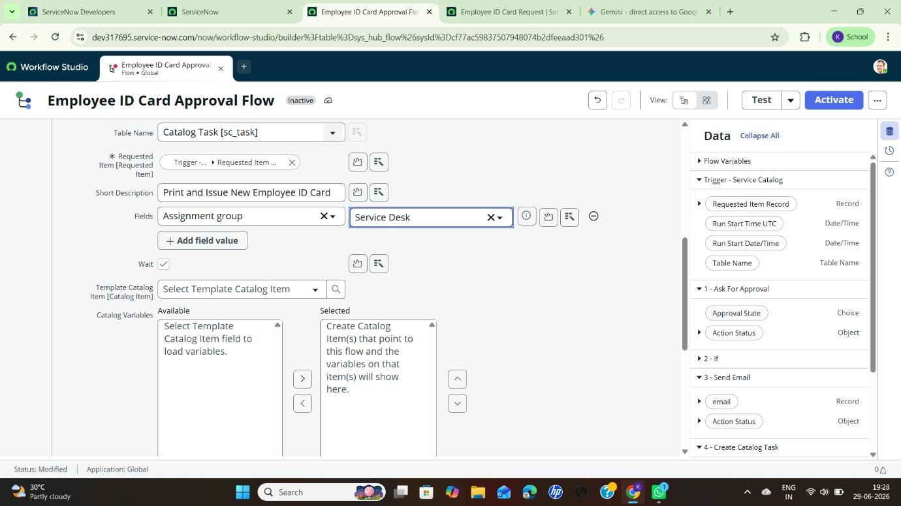

Milestone 5: Testing & Deployment Objective
Connect the flow to the Catalog Item and verify the complete process.
Step 1: Link the Flow Navigation:
All → Service Catalog → Catalog Definitions → Maintain Items

Open Employee ID Card Request. Go to Process Engine.
Select Employee ID Card Approval Flow. Click Update.
Step 2: Test the Catalog Item Click Try It.
Enter: Employee Name Department Reason
Click Order Now.

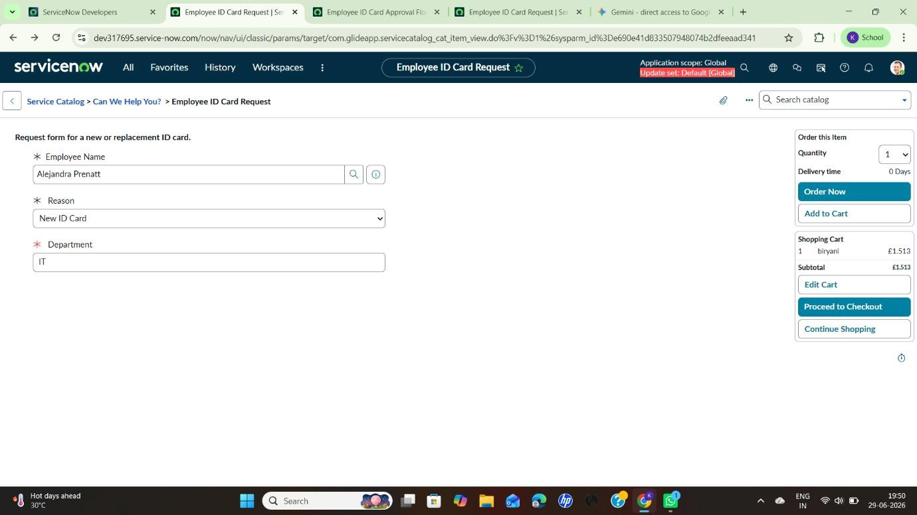

Step 3: Verify Request Creation
Confirm that a REQ and RITM number are generated.

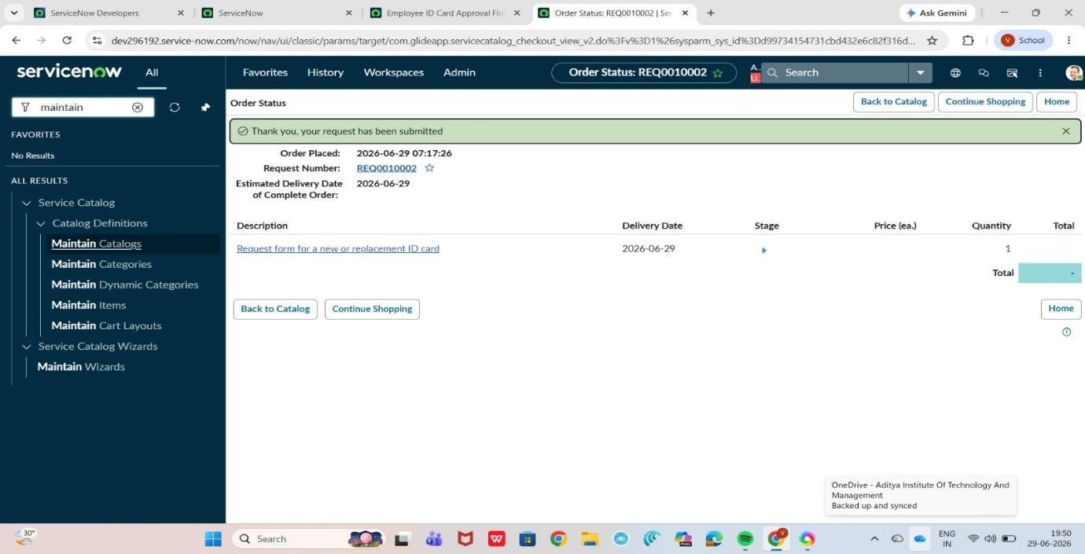
Step 4: Verify Approval Navigation:
All → Requested Items

Open the generated RITM. Check the Approvals related list. Step 5: Verify Catalog Task

Navigation:
All → Service Catalog → Catalog Tasks

Verify that the admin task has been created after approval.
Step 6: Verify Email Notifications Navigation:
All → System Mailboxes → Outbound → Sent

Confirm that approval or rejection email notifications have been sent

Screenshots of Output

1. Flow Execution Test

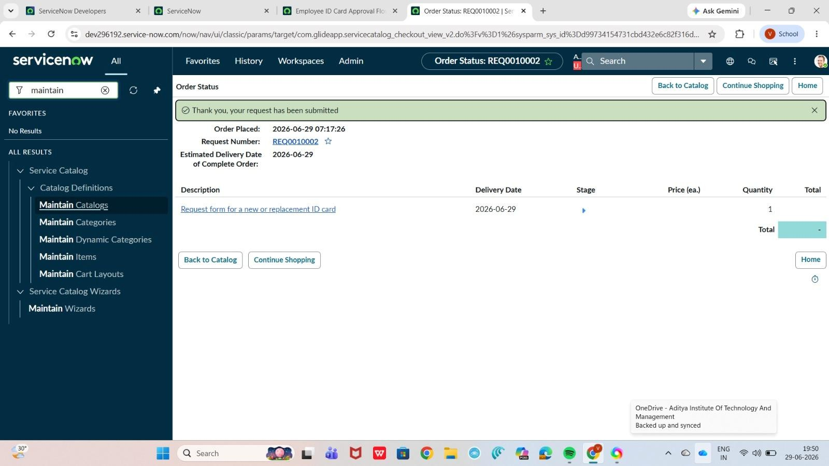

Conclusion
The Employee ID Card Request System demonstrates the effectiveness of using the ServiceNow platform to automate and simplify the employee ID card request process. By utilizing features such as the Service Catalog, Catalog Variables, UI Policies, Flow Designer, Manager Approval, Email Notifications, and Catalog Tasks, the system provides a structured and efficient workflow that manages employee requests from submission to final ID card issuance.The automation implemented in this project significantly reduces manual effort, speeds up request processing, and ensures that every request follows a standardized approval process. Automated manager approvals, instant email notifications, and automatic task creation for the administration team improve communication, enhance transparency, and maintain accurate records throughout the request lifecycle. The system also enables employees and administrators to track request status easily, ensuring accountability and improving service quality.
In conclusion, the project delivers a reliable, scalable, and user-friendly solution for managing employee ID card requests within an organization. It enhances operational efficiency, reduces processing delays, improves employee satisfaction, and ensures compliance with organizational policies. Furthermore, the solution provides a strong foundation for future enhancements, such as supporting temporary ID cards, contractor badges, visitor passes, integration with HR systems, and advanced workflow automation, making it a valuable contribution to modern IT Service Management (ITSM) practices.

